LAB # 06
INTRODUCTION TO PROLOG

Objectives:
- To introduce the basic concepts of prolog
- To get familiar with SWI-Prolog working environment
- To program some logics and run on SWI-Prolog
- To Implement a simple knowledge base

Lab Related Theory:
Introduction to SWI-Prolog Environment
SWI-Prolog is an easy s/w for logical programming. You can build, compile and apply query on your code to retrieve results. It is available for different OS and 32/64 bit architecture. It can be downloaded from following website.
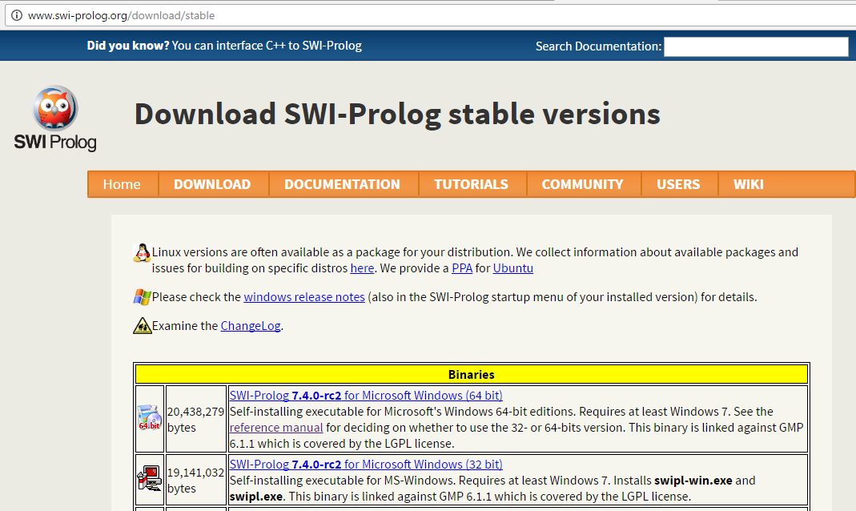
After installation, When you double click on Prolog Icon, it will open the following window.
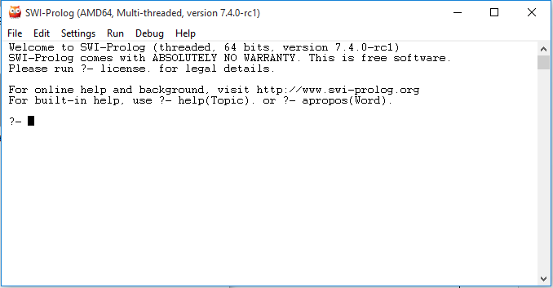
Above window is query build , we don’t wroe code on this window. It is used for writing query. To write a code follow below procedure :
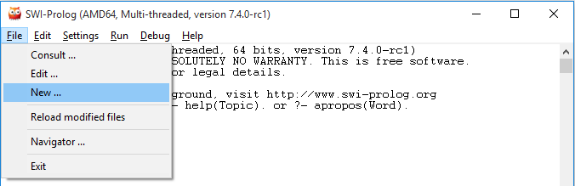
Make a new file with extension “ .pl “ like first.pl
This window will be appear, here you can write a code.
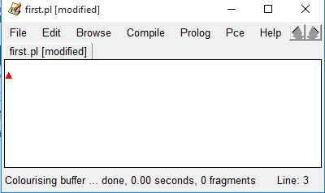

INTRODUCTION TO PROLOG
Prolog stands for "Programming with Logic". It is different from other programming languages and use for artificial programming. It is:
  - Declarative (not procedural)
  - Recursion (no “for” or “while” loops)
  - Relations (no functions)
  - High-level language
  - Think declaratively, not procedurally

Prolog is referred to as a declarative language because all program statements are definitional. In particular, a Prolog program consists of facts and rules which serve to define relations (in the mathematical sense) on sets of values.

Knowledge Base:

Knowledge Base 1 (KB1) is simply a collection of facts. Facts are used to state things that are unconditionally true of some situation of interest

Facts and Rules
Everything in Prolog is defined in terms of two constructs: the fact and the rule
A Fact states that a certain tuple of values satisfies a predicate unconditionally.

A Rule, on the other hand, is a Prolog statement which gives conditions under which tuples satisfy a predicate.
The basic building block of a rule is called an atom:
Atom :- Atom1, ..., Atom

It consists of following parameters:
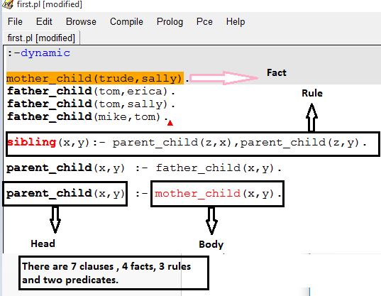

Now write a code .
- Make a new file first.pl from File ->New
- Write above code
- Compile -> Make to save changes of code
- Compile -> Compile buffer
If your code contains error so, it will open prompt window, try to solve those errors.
Other wise check your query builder prolog window. It will show compile message with file path.

Now write your queries , you can check following facts and rules both and attach its results with your lab tasks.
Queries:
mother_child(tom,erica).
father_child(tom,sally).
father_child(z,erica).
mother_child(trude,y).parent

“ . “ This dot is terminator and use in the end of each line.
Second example:
Mia, Jody, and Yolanda are person, Jody plays air guitar, and that a party is taking place, using the following five facts:
Facts:

person (mia).
person (jody).
person (yolanda).
playsAirGuitar(jody).
party.

Rules To check:
listens2music(yolanda):-happy(yolanda).
playsairguitar(mia):-happy(mia).
playsairguitar(yolanda):-listens2music(yolanda).

Lab Tasks
- Write a prolog code for following Scenario. Compile and run it. Also attach results which shows following :
- All facts you have declared.
- Check the facts
Facts
Schedule of classes -- > Per day one course
Difficulty level of course --- > hard, medium, easy
Also write that how many facts, rules, predicates and clauses are present in your code.

- Write a program for Scenario: Arham , Ali , Sobia are three siblings . They have different habits under stress. Sobia eat burgers under stress, Ali go on outing under stress, Arham watch TV under stress.
Write:
All facts you have declared
All rules checked by applying different values in variable.

Learning Outcomes
In this lab we learng the basic concept of prolog and the learning environment

some logics and run on SWI-Prolog

